How to Register a Kroger Card for Dublin Community Rewards
Click on Community at the top and then click community rewards

Click Enroll Now
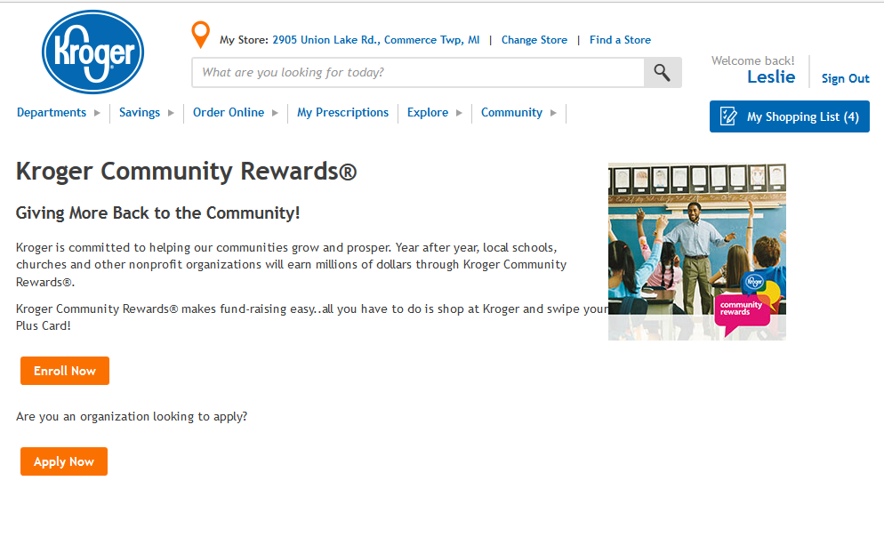
Click Enroll
Type Dublin and click search
Click radio button next to Dublin Elementary. Then click enroll.
There will be a message at the top confirming enrollment. Dublin will show up
in the Community Rewards section at the bottom.

