- Go to https://www.memberhub.com/, enter your email address that was used when enrolling in your PTA membership, and select “I need to create my password”:
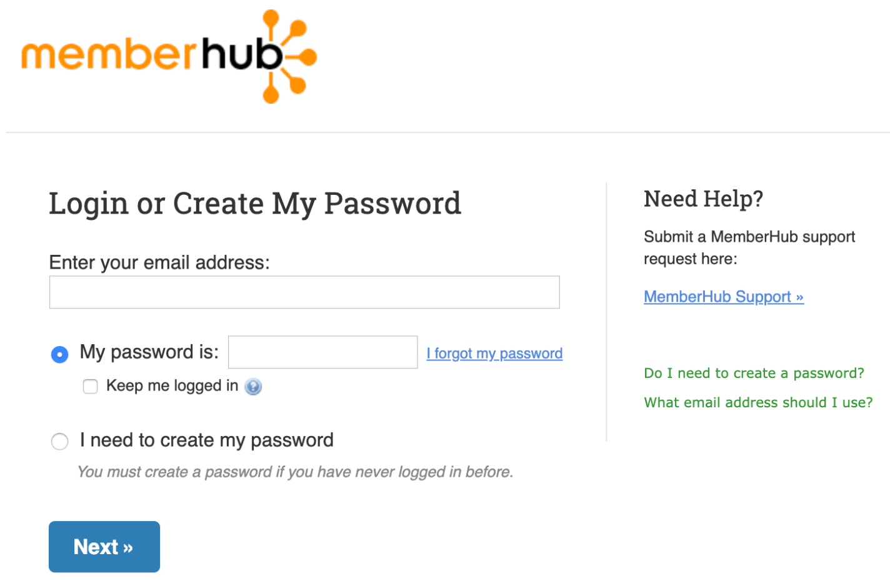

- Select a password for your profile:
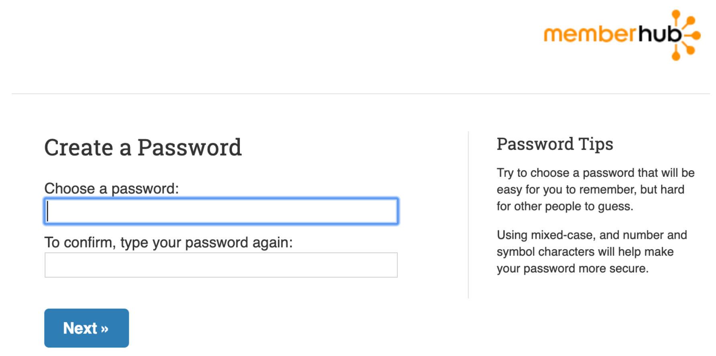

- You will receive an email to confirm your e-mail address entered:

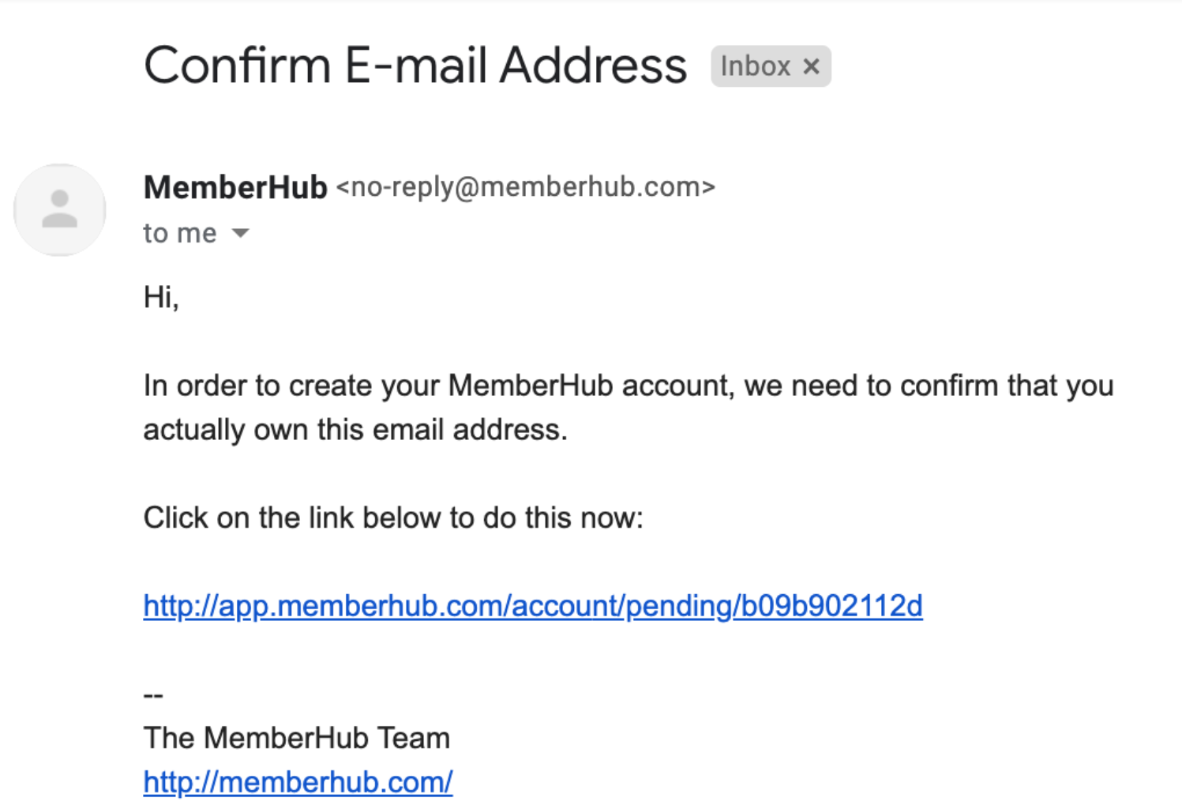

- Log into MemberHub and PTA members will now have access to the PTA directory via the Directory tab at the top of the page. If you are not an active PTA member, you will be prompted to join the PTA to access the directory:
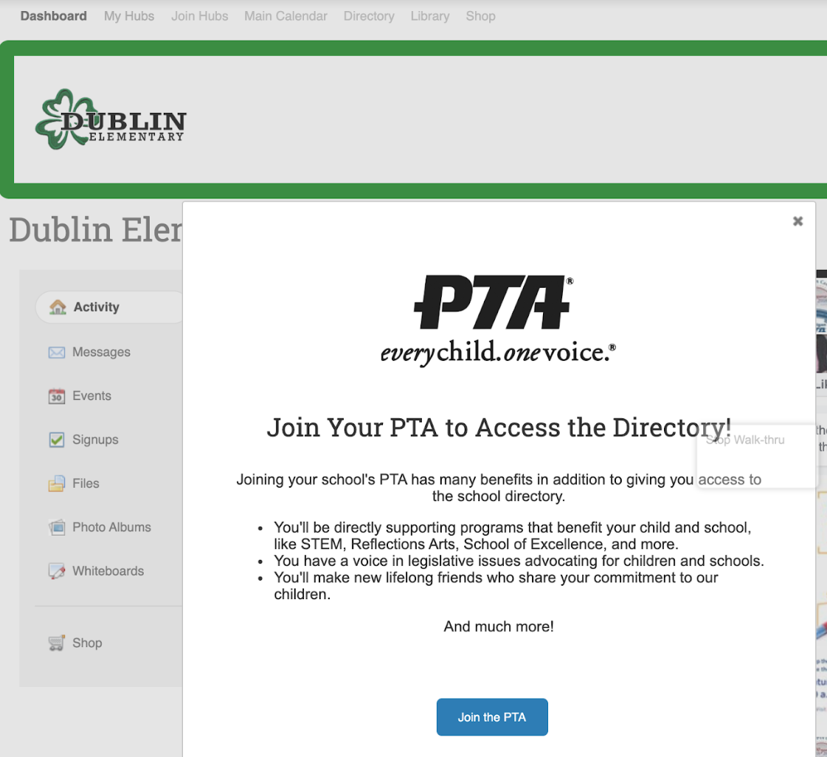
Questions about PTA membership or trouble creating an account? Please contact Mimi Curlee at mimers03@yahoo.com with any questions or concerns.
Frequently Asked Questions (FAQs)
Q: Is there a mobile app available for MemberHub?
A: Yes! MemberHub is also available as a convenient mobile app available for download in the iOS and Google Play stores providing easy access to the Dublin community right at your fingertips!
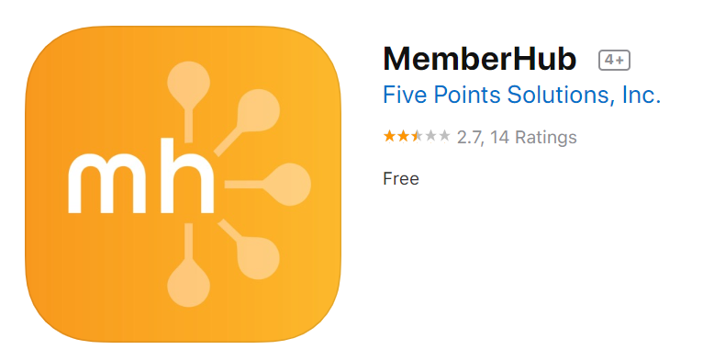
Note:
You cannot create an account directly from the mobile app. You will be required to initially setup your account on your computer.

Q: What if I belong to multiple PTA organizations? Do I have access to all of them in MemberHub?
A: Yes! To switch between organizations, just select your profile name in the upper right hand corner and select the organization you want to view. See sample below:
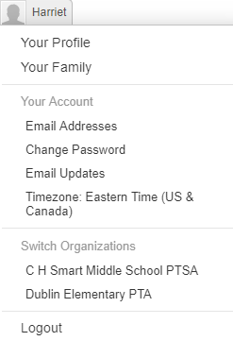

Q: Do I have the ability to view just people in my child’s class list?
A: Yes. Everyone is part of the Dublin Elementary Hub as well as their child/children’s classroom Hub. Just select the My Hubs menu when logged into the website or Your Hubs in the mobile app.

